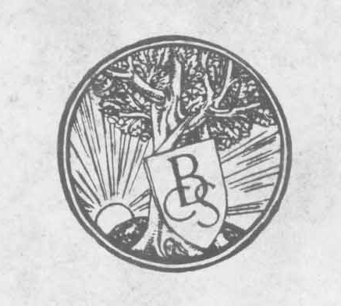
The Birmingham Civic Society.

Notes on Grave Memorials.

The object of a graveyard memorial is to perpetuate a memory. To do this effectively the first essentials are a suitable and enduring material, and lettering of good character that will always be readable.
The dignity and beauty of the simple graveyard monuments to be found in our old churchyards result for the most part from the use of local material and workmanship. The general ugliness of modern cemeteries is due very largely to the use of foreign material and workmanship, the majority of the stones erected being imported. Foreign headstones are usually decorated with architectural details, religious signs and symbols which are worked abroad, the inscription being cut out by the local mason as best he can, in a space invariably unsuited to the words to be used.
English stones are best suited to the subdued tones of' English landscapes and sky. White marble is an osten-tatious and foreign material which does not harmonise
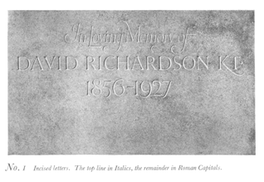

with our conditions. There are many stones quarried in this country that are more enduring than white marble, such as Hopton Wood, Bolton Wood, Darley Dale (Stancliffe While), Scout Brown York, Robin Hood Blue York, Mottled Hollington, Cornish, Aberdeen and Penmaenmawr granites.
An inscription which is addressed to posterity should be simple, concise and carefully worded; its lettering should be well arranged and skilfully cut. Raised or incised letters are equally beautiful. Lead filled letters should always be avoided, and they are unnecessary where English stones are used. Incised block letters

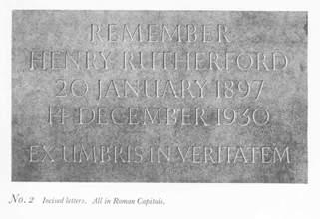

should not be less than 1/4" high, and raised letters 1 1/2", but both types of letter are better if these dimensions are increased. The extent to which a memorial depends for dignity upon the character of its inscription can be seen on pages 2, 3 and 4 of this pamphlet.
It is desirable that the spacing and design of inscriptions for memorials should be submitted to a competent authority for advice before the work is executed.

The Birmingham Civic Society are prepared to give such advice without charge to those about to erect memorials, and a number of specimen inscriptions may be seen at their offices, 37, Bennetts Hill.
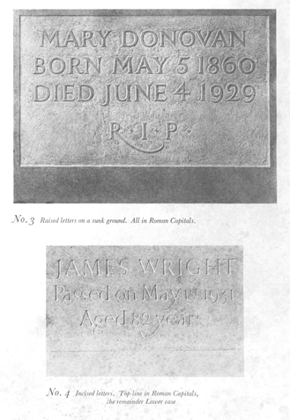
Printed circa 1932, folio.

